In the instructor-generated videos for this Module the instructor several times described the sympathetic and parasympathetic branches of the autonomic nervous system as operating in “push-pull” in their control of cardiac function. Explain what is meant by the term “push-pull” in the context of this module. Answer individually**;**

The sympathetic nervous system and parasympathetic nervous system have usually opposite effects on cardiac functions:

* Adrenergic transmitters which are from the sympathetic system increase the heart rate whereas the cholinergic transmitters from the parasympathetic system reduce it. Changes in the heart rate invokes a reciprocal action of the two systems, meaning that the heart rate in normal conditions increases with a combined decrease in parasympathetic activity and an increase in sympathetic activity; the heart rate decreases with opposite changes of these two systems.
* Sympathetic nervous activity enhances atrial and ventricular contractility, parasympathetic nervous activity decreases contractility of the atria and slightly decreases ventricle contractility.
* Both divisions of the ANS influence the AV node: the sympathetic system increases conduction velocity whereas the parasympathetic system can reduce conduction velocity through the AV node up to the point of stopping it (reference: Module 9, Video 1, Slide 6).
* The “push-pull” operating mode also happens at the local level.

Sympathetic drive releases norepinephrine which binds to β-adrenergic receptors on the cardiac cell membrane. This triggers the release of G proteins which raises intracellular level of cAMP and thus the phosphorylation of various proteins. The combined action of these phosphorylations, causes more Ca++ to enter the cell, and increases the speed up of Ca++ uptake into SR, and decreases sensitivity of TnC for calcium. All these effects are consistent with an increase in contractility and rate of relaxation, and an increase in heart rate. The parasympathetic drive works the other way: ACh released by the vagal nerve interacts with muscarine receptors on the cardiac cell membrane, triggering the release of inhibitory protein G which inhibits adenylate cyclase and the cAMP/protein kinase A cascade. This direct inhibition diminishes the Ca++ conductance of the cell membrane, reduces activation of the calcium channels and hence decreases myocardial contractility (reference: Module 9, Video 3, Slide 9).

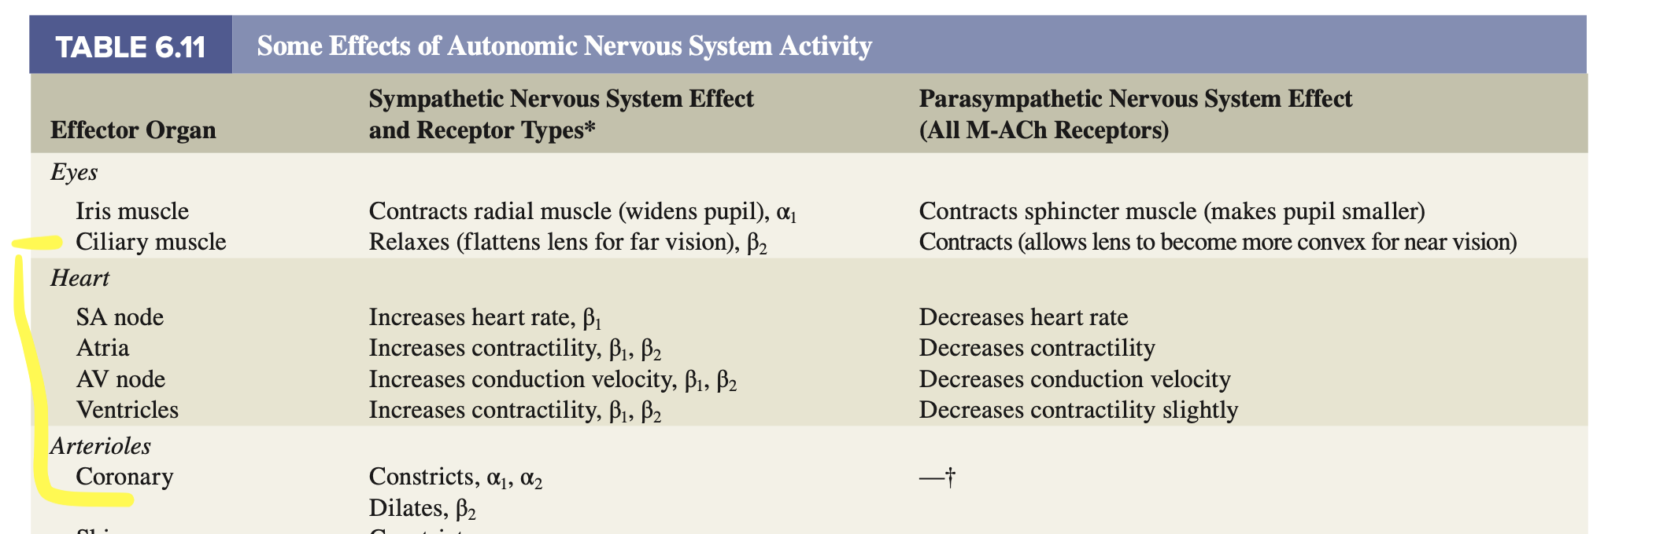

**VSL [15] Table 6.11**

* Sympathetic system has constriction and dilation effects on the vascular system and the parasympathetic system, to some extent, is involved in dilation of the coronary arterioles.